HONORS CHEMISTRY • UNIT 2
Electrons & Periodic Trends
The arrangement of electrons explains the shape of the periodic table, why elements react the way they do, and every trend you will use for the rest of the course.

HOW TO USE THIS PACKET
This is your notebook for the unit. Write definitions in your own words, copy the steps of each worked example, and use the blank space for sketches and questions. Boxes marked LAB CORNER are things you would do or see at a lab bench. Extra practice is at the back.

What we will learn
2.1 | Bohr models & Lewis dot structures
2.2 | The quantum mechanical model & electron configuration
2.3 | Orbital diagrams (Aufbau, Pauli & Hund)
2.4 | Periodic trends: ionization energy & atomic radius
2.5 | Periodic trends: electronegativity & successive ionization energy
★ | Extra practice & unit review

By the end of this unit I can…
• Explain how Bohr’s model improved on Rutherford’s, and use line spectra and flame tests as evidence for energy levels.
• Draw Bohr models and Lewis dot structures and find valence electrons from a periodic table.
• Write full and noble-gas shorthand electron configurations for atoms and ions.
• Draw orbital diagrams that obey the Aufbau principle, the Pauli exclusion principle and Hund’s rule.
• Use Coulomb’s law (nuclear charge, distance and shielding) to explain trends in ionization energy and atomic radius.
• Explain the trend in electronegativity and use successive ionization energies to identify an element’s group.
• Rank atoms and ions in order of radius, ionization energy and electronegativity and justify each ranking.
TOPIC  2.1 | Bohr Models & Lewis Dot Structures  Energy levels • line spectra • valence electrons

BIG IDEA
Bohr proposed that electrons can only exist in certain energy levels (shells) around the nucleus, like steps on a staircase. Electrons jump between levels by absorbing or emitting exactly the right amount of energy.

Key vocabulary — write each definition in your own words
Term | Definition (your words) | Example / sketch
Energy level (shell) | How many e⁻ can the first three levels hold?
Valence electron | Where are they? Why do they matter?
Core electron | How is it different from a valence electron?
Emission spectrum | What makes the lines?
Lewis dot structure | What do the dots stand for?

How did Bohr improve Rutherford’s model?
CUES / KEY WORDS  Rutherford  Bohr  Evidence | COMPARE THE TWO MODELS

THINK OF IT LIKE… A STAIRCASE
On a staircase you can stand on step 1 or step 2, but never in between. Electrons are the same: they can only be at certain energy levels. Moving up a step takes a specific amount of energy; moving down releases the same amount, as light.

LAB CORNER • Line spectra: the fingerprint of an element

When hydrogen gas is heated or energized, it glows. A prism or diffraction grating spreads that light into a spectrum.
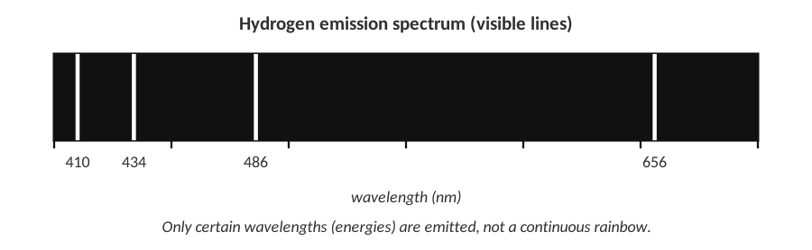 | 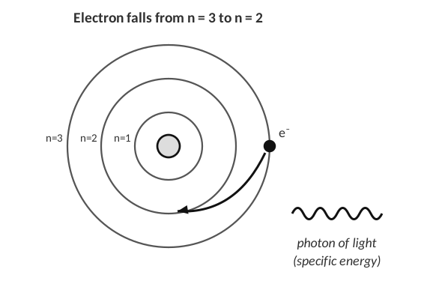
Visible lines in the hydrogen spectrum | An electron falls to a lower level

1. Why does hydrogen emit only a few separate lines and not a continuous rainbow of colors?

2. The line at 410 nm has a shorter wavelength than the line at 656 nm. Which line comes from the larger energy drop? Explain.

3. What happens to an electron when an atom absorbs energy? What happens when it falls back?

LAB CORNER • Flame tests

A student dips a clean wire loop into solutions of metal salts and holds it in a Bunsen burner flame. Each metal ion produces a different flame color.
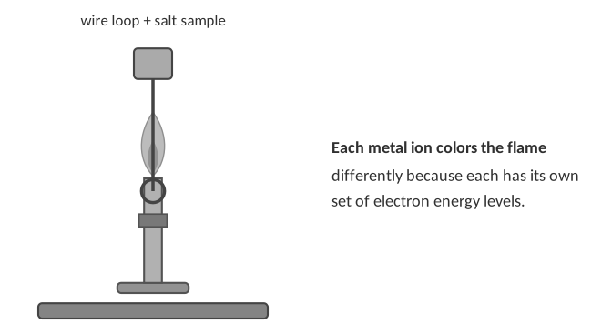
Metal ion in the salt | Flame color observed
Lithium (Li⁺) | crimson red
Sodium (Na⁺) | bright yellow-orange
Potassium (K⁺) | pale lilac / violet
Calcium (Ca²⁺) | orange-red
Copper (Cu²⁺) | blue-green
Barium (Ba²⁺) | yellow-green

4. Explain, using electron energy levels, where the colored light in a flame test comes from and why each metal gives a different color.

5. A student tests a white powder and sees a bright yellow-orange flame. What metal ion is most likely in the powder? Why isn’t flame color alone enough to be certain when the flame is orange-red?

Drawing Bohr models
BOHR MODEL RULES
• The number in the nucleus = atomic number (protons).
• Fill the shells closest to the nucleus first: 2 → 8 → 8 … (up to element 20).
• The electrons in the last shell are the valence electrons.

Draw the Bohr model for each element. Write the number of protons in the nucleus and place dots for electrons on the rings.
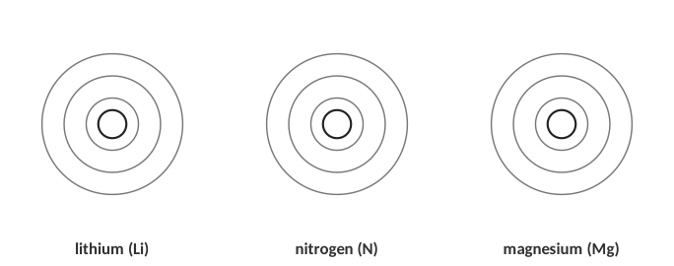
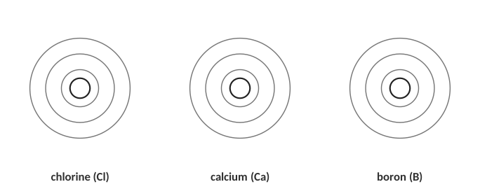
6. How do you find the number of valence electrons for an element using the periodic table?

Group | 1 | 2 | 13 | 14 | 15 | 16 | 17 | 18
Valence electrons

Lewis dot structures
THINK OF IT LIKE… SEATS ON A SQUARE TABLE
Put one dot on each side of the symbol (top, right, bottom, left) before you pair any up. This is like people sitting at a square table: everyone takes their own side first.

Draw the Lewis dot structure for each element.
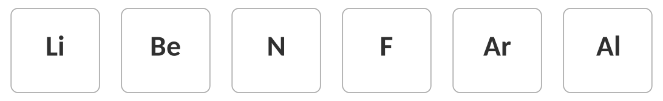
Identify the element
Clue | Element
Has 5 valence electrons and is in period 3.
Has 7 valence electrons and its most abundant isotope has 18 neutrons.
Has 8 valence electrons and is in period 2.
Has a Bohr model with 2, 8, 2 electrons in its shells.

WATCH OUT!
Valence electrons are counted by the outermost shell, not by the total number of electrons. Sodium has 11 electrons but only 1 valence electron.

[ IMAGE GOES HERE ]
Optional: Bohr model diagrams from your Topic 2.1 homework (identify the elements)

7. An electron in an atom absorbs energy. What happens next?
A) It moves to a lower energy level.
B) It moves to a higher energy level.
C) It leaves the nucleus.
D) It becomes a proton.

TOPIC  2.2 | The Quantum Mechanical Model & Electron Configuration  Sublevels • orbitals • Aufbau order

BIG IDEA
Electrons don’t circle the nucleus like planets. They occupy orbitals, 3-D regions where an electron is most likely to be found. Orbitals are grouped into sublevels (s, p, d, f) inside each energy level. An electron configuration lists where every electron is.

Key vocabulary — write each definition in your own words
Term | Definition (your words) | Example / sketch
Orbital | How many electrons fit in one?
Sublevel (s, p, d, f) | How many orbitals in each?
Electron configuration | What does 2p⁴ mean?
Aufbau principle | Which sublevels fill first?
Noble gas shorthand | Why do we use it?

THINK OF IT LIKE… AN APARTMENT BUILDING
The energy level is the floor of the building (n = 1, 2, 3 …). Each floor has different types of rooms (s, p, d, f). Each room is an orbital, and every room holds at most 2 people. People take the cheapest, lowest rooms first, and the building gets bigger as you go up (floor 1 has just an s room; floor 3 has s, p and d rooms).

Sublevel | Shape | Number of orbitals | Max electrons
s
p
d
f

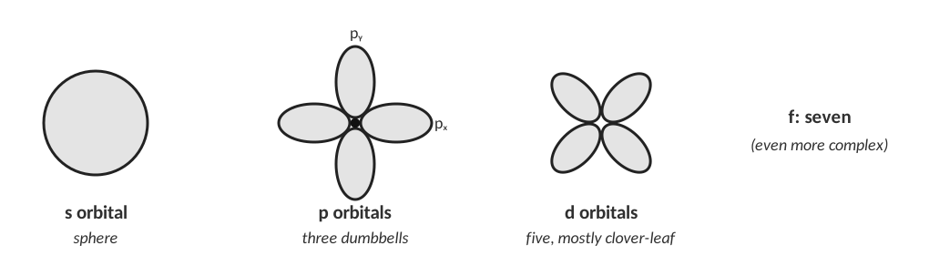
Orbital shapes (not to scale).
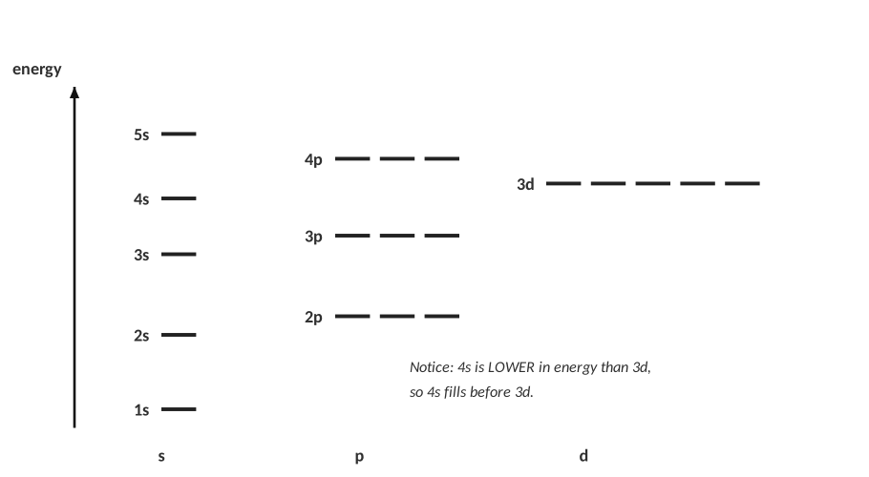
Relative energies of the sublevels.
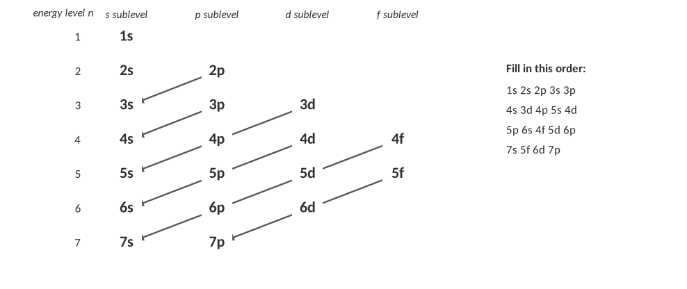
The diagonal rule: follow each arrow from top right to bottom left.
CUES / KEY WORDS  Aufbau  Order | WRITE THE FILLING ORDER FROM MEMORY (USE THE DIAGRAM AS A GUIDE)

The periodic table is a map of the filling order
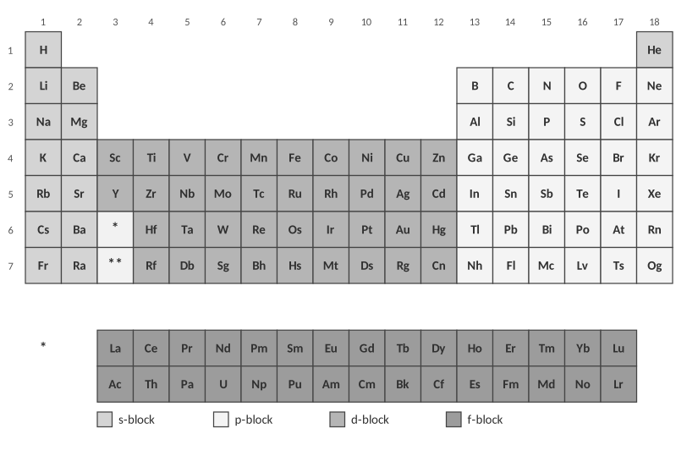
Blocks of the periodic table.
1. Use the table above to explain why the periodic table has a block of 2 columns on the left, 6 on the right, and 10 in the middle.

Worked examples
WORKED EXAMPLE — FULL CONFIGURATION
Write the electron configuration for nitrogen (7 electrons).

Work it out here:

Answer: __________________________________
WORKED EXAMPLE — SHORTHAND
Write the noble gas shorthand for arsenic (As, 33 electrons).

Work it out here:

Answer: __________________________________
WORKED EXAMPLE — IDENTIFY FROM THE CONFIGURATION
Which element has the configuration 1s² 2s² 2p⁶ 3s² 3p⁴?

Work it out here:

Answer: __________________________________
QUICK TRICKS
• The period number is the highest energy level (n) in the configuration.
• Valence electrons = electrons in the highest energy level (the s and p electrons of the outer shell).
• Superscripts always add up to the atomic number (for a neutral atom).

Practice: write the full configuration, then circle the valence electrons
Element | Electron configuration | Valence e⁻
Be (Z = 4)
Mg (Z = 12)
Ca (Z = 20)

2. What do the configurations of Be, Mg and Ca have in common? Why does this make sense?

Element | Electron configuration | Valence e⁻
N (Z = 7)
Cl (Z = 17)
Mn (Z = 25)
Cd (Z = 48)

Practice: noble gas shorthand
Element | Shorthand configuration
Sr (Z = 38)
As (Z = 33)
S (Z = 16)
Al (Z = 13)

Practice: identify the element
Configuration | Element
1s² 2s² 2p⁶ 3s¹
[Kr] 5s² 4d¹⁰ 5p³
1s² 2s² 2p⁶ 3s² 3p⁶ 4s² 3d¹⁰ 4p⁶ 5s² 4d¹⁰ 5p³
[Ne] 3s² 3p²

Find the error
Each configuration below is for a neutral atom. Is it correct? If not, explain what is wrong and write the correct one.
Configuration | Correct? If not, fix it
1s² 2s² 2p⁶ 3s³
1s² 2s² 2p⁷
1s² 2s¹ 2p⁵
[Ar] 4s² 3d¹⁰ 4p⁵
[Ar] 5s² 4d¹⁰ 5p⁵

Configurations of ions
CUES / KEY WORDS  Cations  Anions  Isoelectronic | HOW DO YOU WRITE THE CONFIGURATION OF AN ION?

Ion | Configuration | Same configuration as which noble gas?
Na⁺
O²⁻
Mg²⁺
Cl⁻
Ca²⁺
Al³⁺

REAL WORLD
Atoms “want” a filled outer shell like a noble gas. That is why sodium readily forms Na⁺ and chlorine forms Cl⁻: they end up with the same stable configuration as neon and argon. This is the whole story of ionic bonding (Unit 9).

3. How many electrons can the 3d sublevel hold?
A) 2
B) 6
C) 10
D) 14

4. Which is the correct shorthand configuration for calcium?
A) [Ne] 3s²
B) [Ar] 4s²
C) [Ar] 3d²
D) [Kr] 4s²

TOPIC  2.3 | Orbital Diagrams  Aufbau • Pauli exclusion • Hund’s rule

BIG IDEA
An orbital diagram shows every orbital as a box and every electron as an arrow. It tells you more than a configuration: it shows which electrons are paired and which are unpaired, and that decides how an atom behaves in a magnetic field and in bonding.

Key vocabulary — write each definition in your own words
Term | Definition (your words) | Example / sketch
Orbital | How many electrons can one orbital hold?
Pauli exclusion principle | What must be different about two electrons in the same box?
Hund’s rule | What do electrons do in a sublevel with several boxes?
Paired / unpaired electron | How can you tell from a diagram?
Degenerate orbitals | Which orbitals are degenerate?

THINK OF IT LIKE… SEATS ON A BUS
Strangers boarding a bus take an empty double-seat to themselves before sitting next to someone (Hund’s rule). Only when every double-seat has one person does anyone sit beside a stranger. Each seat holds at most two people, and they must be facing opposite directions (Pauli). Passengers fill the front rows first (Aufbau).

The three rules — write each one in your own words
CUES / KEY WORDS  Aufbau principle  Pauli exclusion principle  Hund’s rule | STATE EACH RULE AND SKETCH A SMALL EXAMPLE

How to draw an orbital diagram
STEPS
1. Write the electron configuration first (so you know how many electrons go in each sublevel).
2. Draw boxes: 1 box for s, 3 for p, 5 for d, 7 for f.
3. Add arrows one at a time, ↑ first in every box of the sublevel (Hund), then add ↓ to pair them.
4. Check: the total number of arrows equals the atomic number, and no box holds more than two arrows.

WORKED EXAMPLE — NITROGEN
Draw the orbital diagram for nitrogen (Z = 7).

Work it out here:

Answer: __________________________________
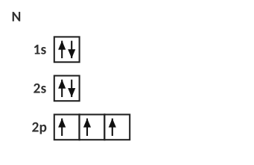
Nitrogen: three unpaired electrons.
WORKED EXAMPLE — IRON
Draw the orbital diagram for iron (Z = 26) and count its unpaired electrons.

Work it out here:

Answer: __________________________________
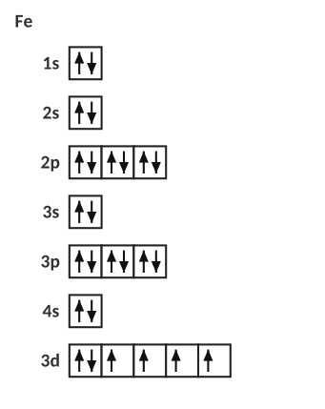
Iron: four unpaired electrons in 3d.
Practice: complete the orbital diagram
Fill in the arrows. Then write the number of unpaired electrons.
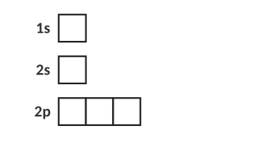
O (Z = 8): unpaired electrons = ________
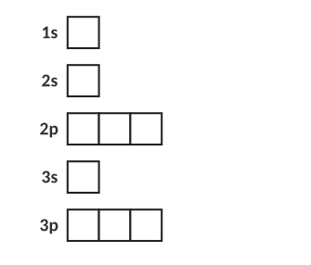
P (Z = 15): unpaired electrons = ________
Find the error
Each diagram below is meant to show nitrogen’s outer electrons (2s and 2p). Only one is correct. For the other two, name the rule that is broken.
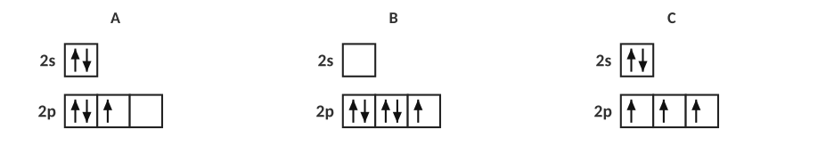
1. Which diagram is correct, and what rule is broken in each of the others?

Unpaired electrons across period 3
Element | Shorthand configuration | Unpaired e⁻ | Attracted to a magnet?
Na
Mg
Al
Si
P
S
Cl
Ar

2. Describe the pattern in the number of unpaired electrons as you move across period 3. Why does it go up and then back down?

Orbital diagrams for ions
3. Draw the 2p orbital boxes for O (2p⁴) and for O²⁻. How many unpaired electrons does each have? Why is O²⁻ stable?

4. Write the electron configuration and count the unpaired electrons for Fe²⁺ and Fe³⁺. (Remove the 4s electrons first.)

Extension: photoelectron spectroscopy (PES) as evidence for sublevels
In PES a sample is hit with high-energy light and the energy needed to remove each electron is measured. Each peak is one sublevel; the height is the number of electrons in it. Peaks farther left need more energy (those electrons are closest to the nucleus).
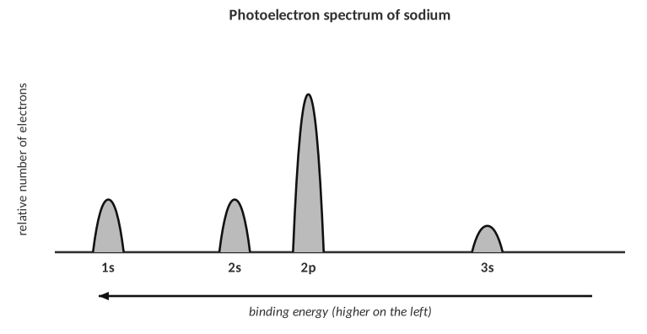
5. The PES for an unknown element shows three peaks with relative heights 2 : 2 : 1 (left to right). Which element is it? Write its configuration.

6. In the sodium spectrum, why is the 1s peak farthest to the left?

7. How many unpaired electrons does a ground-state atom of sulfur have?
A) 0
B) 1
C) 2
D) 4

8. Which rule is broken if two electrons in the same orbital both point up?
A) Aufbau
B) Hund
C) Pauli exclusion
D) Dalton

9. Which element has exactly three unpaired electrons?
A) Si
B) P
C) S
D) Cl

TOPIC  2.4 | Periodic Trends I: Ionization Energy & Atomic Radius  Coulomb’s law • nuclear charge • distance • shielding

BIG IDEA
Almost every periodic trend comes from one idea: opposite charges attract. The nucleus (+) pulls on the electrons (−). How hard it pulls depends on how many protons, how far away the electron is, and how many other electrons are in the way.

Key vocabulary — write each definition in your own words
Term | Definition (your words) | Example / sketch
Atomic radius | How is it measured, and in what units?
Ionization energy (IE) | Does it take energy or release it?
Effective nuclear charge (Zeff) | Is it larger or smaller than the real nuclear charge?
Shielding | Which electrons do the shielding?
Coulomb’s law | What are the three factors?

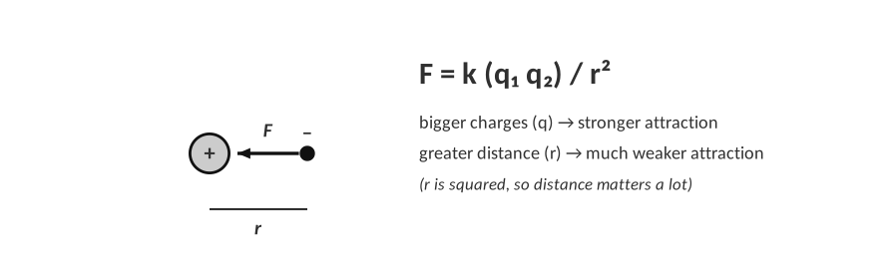
Coulomb’s law: the pull on an electron.
THINK OF IT LIKE… A MAGNET AND A PAPERCLIP
A paperclip held close to a magnet jumps to it. Move it a little farther away and the pull almost disappears (distance). Use a stronger magnet and the pull grows (nuclear charge). Put a thick book between them and the pull is weakened (shielding). An outer electron feels the nucleus exactly like that paperclip.

The three factors — your own words
CUES / KEY WORDS  Nuclear charge  Distance  Shielding | HOW DOES EACH FACTOR CHANGE THE PULL ON AN OUTER ELECTRON?

Effective nuclear charge across period 3
Element | Protons | Core (inner) e⁻ | Zeff ≈ protons − core | Valence e⁻
Na | 11 | 10
Mg | 12 | 10
Al | 13 | 10
Si | 14 | 10
P | 15 | 10
S | 16 | 10
Cl | 17 | 10
Ar | 18 | 10

1. What happens to the effective nuclear charge as you go left to right across a period? Does the number of energy levels change?

Atomic radius
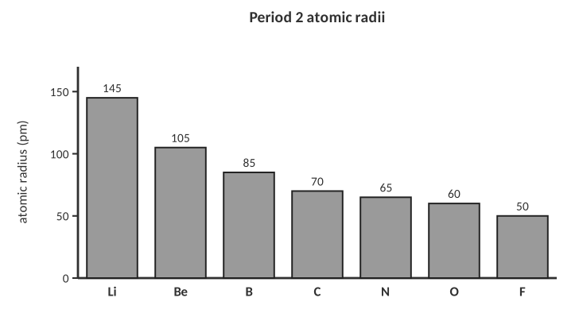
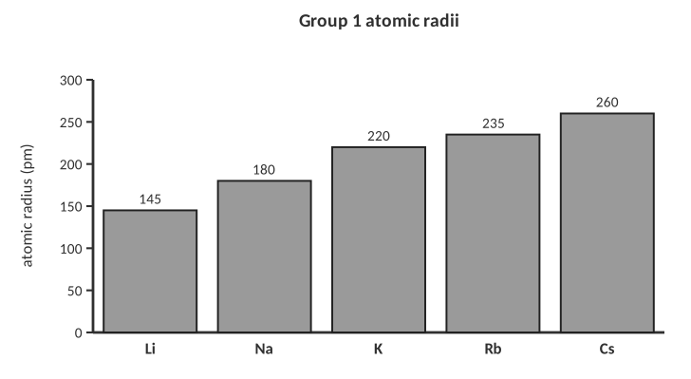
Radii shown are empirical atomic radii (pm); different sources give slightly different numbers but the same trends.
2. State the trend in atomic radius (a) across a period and (b) down a group.

Write a full explanation (CER)
CER FRAME
Claim: what is the trend or the answer?
Evidence: quote a fact, a number or a position on the table.
Reasoning: use nuclear charge, distance and shielding (Coulomb’s law) to explain WHY.

3. Explain why a sodium atom is larger than a chlorine atom, using principles of atomic structure and Coulomb’s law.

4. Explain why a potassium atom is larger than a sodium atom, using Coulomb’s law.

Bohr models: lithium and sodium
Draw Bohr models for Li and Na. Show the correct number of electrons in each shell and circle the valence electron.
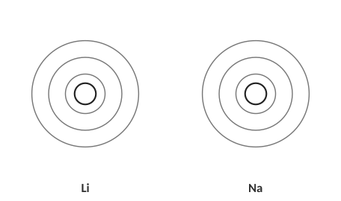
5. Using your models, explain which atom holds its valence electron more tightly.

First ionization energy
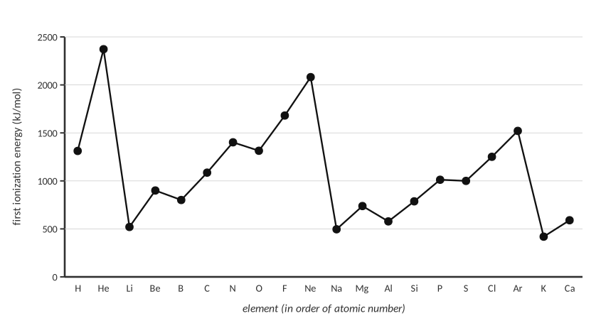
First ionization energy of elements 1–20.
6. Describe the overall pattern across a period and down a group in the graph.

7. Explain why the ionization energy drops sharply from neon to sodium.

8. Explain why helium has the largest first ionization energy of all the elements.

Two small exceptions
Look at the graph again: boron is slightly lower than beryllium, and oxygen is slightly lower than nitrogen. Use the configurations to explain one of them.
9. Explain why oxygen’s first IE is lower than nitrogen’s.

Ranking practice
Rank from lowest to highest | Answer
First ionization energy: Li, Be, B, N, O, F
Atomic radius (smallest to largest): N, P, As, Sb, Bi, Mc
Atomic radius (smallest to largest): Na, Mg, Al, Si, Cl
First ionization energy (lowest to highest): Cs, K, Na, Li

10. For each ranking above, circle the factor that matters most: nuclear charge, distance or shielding. Justify the second one in a sentence.

11. Which atom has the largest atomic radius?
A) Mg
B) Cl
C) Al
D) Na

12. Which of these has the lowest first ionization energy?
A) Li
B) Na
C) K
D) Be

13. The main reason ionization energy increases left to right across a period is that…
A) there are more energy levels
B) effective nuclear charge increases
C) shielding increases a lot
D) atoms get larger

TOPIC  2.5 | Periodic Trends II: Electronegativity & Successive Ionization Energy  Pull in a bond • ions • families

BIG IDEA
Electronegativity tells you how strongly an atom pulls on shared electrons in a bond. Successive ionization energies tell you how many valence electrons an atom has: the jump in energy shows where the core begins.

Key vocabulary — write each definition in your own words
Term | Definition (your words) | Example / sketch
Electronegativity (EN) | In which situation is it used?
Successive ionization energies | What do IE₁, IE₂, IE₃ mean?
Cation | What happens to its size?
Anion | What happens to its size?
Isoelectronic | What do the species share?

Electronegativity
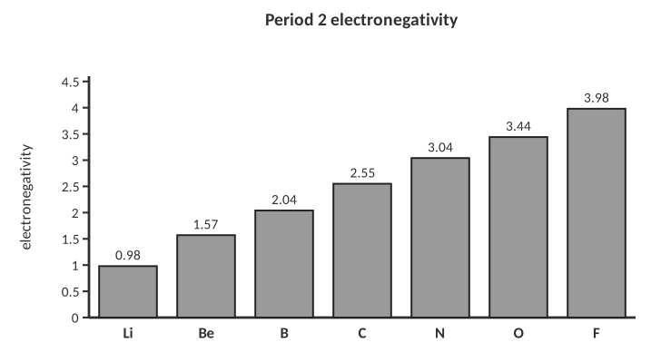
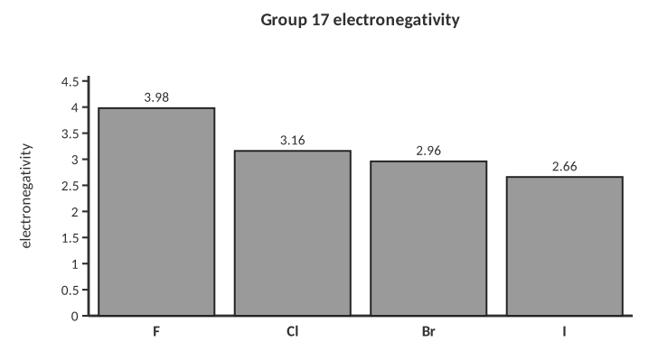
1. State the trend in electronegativity across a period and down a group. Which element is the most electronegative?

2. Explain the trend across a period using nuclear charge, distance and shielding.

3. Why don’t the noble gases usually have electronegativity values?

Rank (lowest to highest EN) | Answer
Na, Cl, Al, P
O, S, Se, Te
C, N, O, F

Ionic radius: why are cations small and anions big?
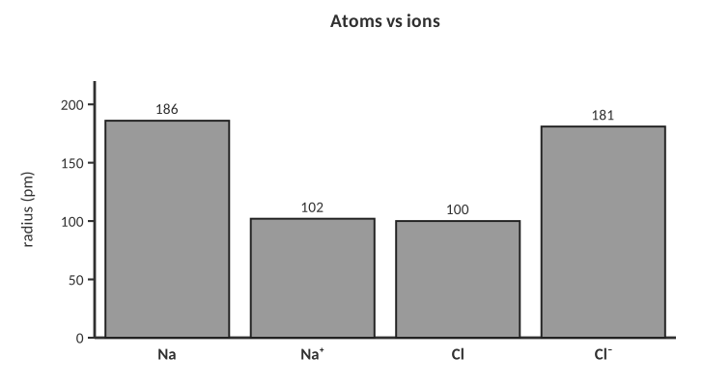
4. Explain why Na⁺ is smaller than Na and Cl⁻ is larger than Cl.

Isoelectronic series
Ion | Protons | Electrons | Configuration
N³⁻
O²⁻
F⁻
Na⁺
Mg²⁺
Al³⁺

5. Rank these six ions from largest to smallest radius and explain the pattern.

Successive ionization energies
THINK OF IT LIKE… PEELING LAYERS
Imagine unwrapping a gift in several layers. The outside layers come off easily, but once you reach the core of the gift it is held tightly. For an atom, the valence electrons are the easy outer layers; the core electrons are very hard to remove, so you see a huge jump in energy.

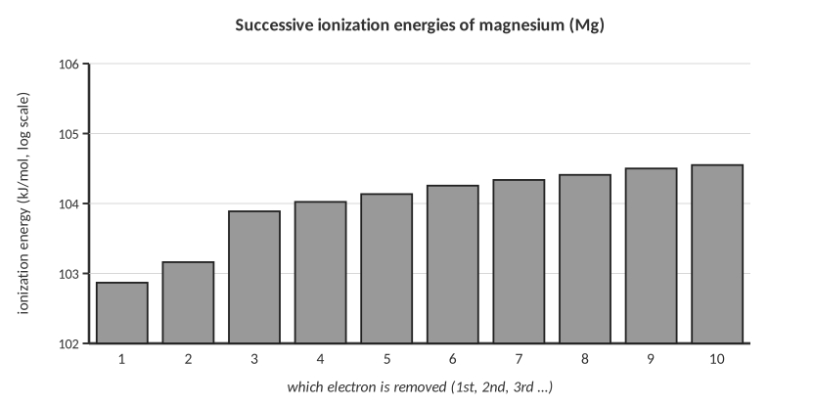
6. Where is the big jump in the Mg data, and what does it tell you about magnesium?

An unknown element's successive ionization energies (kJ/mol) are:
IE₁ | IE₂ | IE₃ | IE₄ | IE₅
786 | 1577 | 3232 | 4356 | 16091

7. In which group does this element belong? Explain, and name one possible element.

IE₁ | IE₂ | IE₃ | IE₄ | IE₅
590 | 1145 | 4912 | 6491 | 8153

8. Repeat for this second unknown.

Fluorine versus iodine
9. The first ionization energy of fluorine is 1681 kJ/mol and iodine is 1008 kJ/mol. Explain why fluorine’s is so much higher.

Why do members of a family act alike?
10. Explain, using electron configurations, why sodium and potassium react in similar ways with water.

Word bank review
Fill in the blanks using the word bank: decreases, increases, nuclear charge, shielding, distance, valence, core.
11. As you move left to right across a period, atomic radius ____________ because the ____________ increases while the number of energy levels stays the same.

12. As you move down a group, ionization energy ____________ because the valence electrons are farther away and more ____________ by core electrons.

13. A big jump in successive ionization energies shows you have started removing a ____________ electron.

14. Electronegativity ____________ from left to right across a period.

15. Which species has the smallest radius?
A) Na⁺
B) Mg²⁺
C) F⁻
D) O²⁻

16. An element has IE₁ through IE₆ of 578, 1817, 2745, 11577, 14842, 18379. It is probably in group…
A) 1
B) 2
C) 13
D) 14

17. Which atom is the most electronegative?
A) O
B) N
C) Cl
D) S

PRACTICE
Extra Practice — Unit 2
Work these on your own or with a partner. Show all work.

A. Electron configurations
Element | Full configuration | Noble-gas shorthand | Valence e⁻
Li (Z = 3)
F (Z = 9)
Si (Z = 14)
K (Z = 19)
Ti (Z = 22)
Ga (Z = 31)
Br (Z = 35)
I (Z = 53)

Ions
Ion | Configuration | Isoelectronic with
K⁺
S²⁻
Br⁻
Sr²⁺
Li⁺
P³⁻

Identify the element
Clue | Element
1s² 2s² 2p⁶ 3s² 3p³
[Ar] 4s² 3d¹⁰ 4p²
[Kr] 5s²
Period 3 element with 6 valence electrons
Halogen with the configuration ending 4p⁵
The alkali metal with four energy levels

B. Orbital diagrams
Draw the orbital diagram for each atom and write the number of unpaired electrons.
C (Z = 6): unpaired electrons = ______
S (Z = 16): unpaired electrons = ______
Cl (Z = 17): unpaired electrons = ______
1. Atoms of which element in period 2 have the most unpaired electrons? How many?

2. Explain, using Hund’s rule, why carbon’s two 2p electrons are in different orbitals.

C. Bohr models and Lewis dot structures
Atom | Protons | Electrons per shell | Valence e⁻ | Lewis dot structure (draw)
Mg
O
Ar
B
Ca

3. Why do elements in the same group have the same number of valence electrons? Give an example.

D. Trends
Rank | Answer
Atomic radius, smallest to largest: S, Na, Cl, Mg
Atomic radius, smallest to largest: Ca, Be, Mg, Sr
First ionization energy, lowest to highest: Ar, Na, Mg, Cl
First ionization energy, lowest to highest: Ne, Kr, He, Ar
Electronegativity, lowest to highest: P, Cl, Si, Na
Ion radius, smallest to largest: S²⁻, Ca²⁺, K⁺, Cl⁻

4. For the last ranking, explain in a sentence or two why it is the order you chose.

5. Explain why magnesium has a higher first ionization energy than sodium. Use Coulomb’s law.

6. Explain why the atomic radius of chlorine is smaller than that of sulfur.

7. Explain why the first ionization energy of lithium is higher than that of cesium.

E. Data analysis
The table lists the first four ionization energies (kJ/mol) of four unknown elements, W, X, Y and Z, from period 3.
Element | IE₁ | IE₂ | IE₃ | IE₄ | Group?
W | 496 | 4562 | 6910 | 9543
X | 738 | 1451 | 7733 | 10543
Y | 578 | 1817 | 2745 | 11577
Z | 786 | 1577 | 3232 | 4356

8. Complete the last column, then name each element (all are in period 3).

9. Which element would form a +3 ion most easily? Explain using the data.

F. Lab corner: flame tests and line spectra
Flame test: the same metal ions are held in a flame on a wire loop; the flame colour identifies the metal.
Emission spectrum of hydrogen (bright lines on a dark background).
10. A lab student puts a salt in a flame and sees a red-orange glow. A second salt gives green. Explain at the level of electrons what is happening to produce the light.

11. Why does hydrogen give lines rather than a continuous rainbow?

12. The student wants to identify an unknown metal. Explain why a flame test or a line spectrum is better evidence than colour of the solid.

[ IMAGE GOES HERE ]
Add AP or homework figure: periodic table or Bohr diagram

G. Quick checks (multiple choice)
13. Which electron configuration represents an excited state of neon?
A) 1s² 2s² 2p⁶
B) 1s² 2s² 2p⁵ 3s¹
C) 1s² 2s² 2p⁶ 3s¹
D) 1s² 2s² 2p⁴

14. Which of the following has the same electron configuration as an Ar atom?
A) Na⁺
B) Cl⁻
C) F⁻
D) Mg²⁺

15. The ion with the largest radius is
A) Mg²⁺
B) Na⁺
C) F⁻
D) O²⁻

16. Which sublevel is filled right after 4s?
A) 4p
B) 3d
C) 4d
D) 5s

17. Which element has the highest first ionization energy?
A) Na
B) Mg
C) Al
D) Cl

TOPIC  ★ | Unit 2 Review  Put it in your own words before the test

1. In three or more sentences, explain how Bohr’s model improved on Rutherford’s and what evidence supports energy levels.

2. What do the three rules (Aufbau, Pauli, Hund) say, and how do they work together to build an orbital diagram?

3. Describe the three factors in Coulomb’s law that explain periodic trends and tell how each one changes across a period and down a group.

4. Explain how successive ionization energy data identify an element’s group.

Draw a periodic table sketch and label the trends
Sketch:

